1. 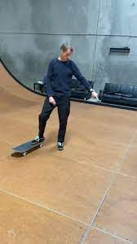Tony Hawk has a mass of 78 kg steps off a stationary skateboard which has a mass of 2.4 kg, knowing that he stepped away forward with an initial velocity of 0.2 m/s , calculate the velocity of the skateboard moving backwards
2. A car with a mass of 2050 k*g* travelling forward at 35 km/h collides with a stationary truck with a mass of 4177 k*g* at what speed will both cars move after the collision
3. A 9kg bowling ball rolls at 1.7m/s into a pillow, and stops in 0.5 seconds.
   1. Calculate the momentum of the bowling ball
   2. What was the force exerted by the bowling ball on the pillow
4. A car with a mass of 1800 kg travelling at 35 km/h, what force will be needed to decelerate it to stop in 5 seconds?